Focus on the Target: The Role of Attentional Focus in Decisions about War and Peace

Kayla N. Jordan

Erin M. Buchanan

Missouri State University

Focus on the Target: The Role of Attentional Focus in Decisions about War and Peace

Words permeate the realm of intergroup relations. Whether slurs and hate speech are used to derogate members of the outgroup or political myths used to unite the ingroup (Esch, 2010; Meeus et al., 2009), words in the midst of intergroup conflict can escalate a situation to violence or help bring about peace. Words can also serve to justify the actions of one group against another group (Burgarski, 2000; Hogenraad, 2005). In the current study, we explore debates in the U.S. Congress regarding U.S. military involvement in Kosovo, Iraq, and Libya to determine whether or not the language used in these debates predicted support for military action.

**Language Analysis**

Discourse is the fusion of content and style words. Within any given sample of language, content words answer the question of what is being said, while style words answer the question of how it is being said. Content words include mostly nouns, verbs, and adjectives, and style words include mostly pronouns, prepositions, articles, conjunctions, negations, and quantifiers (Pennebaker, 2011). The Linguistic Inquiry and Word Count (LIWC; Pennebaker, Booth, & Francis, 2007) is a program developed to summarize these words and others broken down into 82 language categories. Besides style words, the LIWC measures constructs including: a) cognitive mechanisms, such as *know*, *because*, and *none* reflecting causation, exclusivity, and certainty, b) social and emotional words, which include words reflecting social processes and positive and negative emotion, c) relativity, such as *go*, *down*, and *until* reflecting motion, space, and time, d) and personal concerns, which include words reflecting achievement, money, death, and religion among others.

Discourse analysis has become a popular trend to understand psychological correlates tied to language. Tausczik and Pennebaker (2009) reviewed over 100 articles that used language as a basis for studying other constructs; specifically, these studies investigated how categories in the LIWC are related to psychological phenomena, such as attention, emotionality, dominance, and deception.

**Attentional Focus**

Just as a person’s gaze can illuminate where their attention is so can the words they use. Specifically, pronouns and verb tense can demonstrate attentional focus by indicating who or what someone is attending to in a situation and how they are processing the situation. Therefore, greater use of first person pronouns indicated a self focus, third person pronouns indicated a focus on others, and verb tense indicated whether the focus was on past, present, or future events (Tausczik & Pennebaker, 2009). Attentional focus in the form of pronouns has been linked to depression (Rude, Gortner, & Pennebaker, 2004), bullying (Kowalski, 2000), and marital satisfaction (Simmons, Gordon, & Chambless, 2005). Little research has examined the attentional focus in intergroup conflict situations. Abe (2012), examining a forum discussing the Iraq War in 2002-2003, found supporters of the war tended to have an external focus, using more third person pronouns, and tended to use more time related words. Matasumoto and Hwang (2015) also found greater use of plural third person pronouns (i.e. *we, us*) predicted aggressive acts by groups by examining historical texts. Based on these studies as well as previous research on intergroup conflict, we suggest those who perceive greater threat to the ingroup may focus more negative attention on the outgroup and focus on past events between the groups (Meeus et al., 2009). The purpose of the current studies is to determine if attentional focus is different for members of Congress who support war measures versus those who oppose them.

**Hypotheses**

H1: Supporters of war measures will focus on other people and will therefore use more third person pronouns (Abe, 2012; Matasumoto & Hwang, 2015).

H2: Supporters of wars measures will focus on past events and will therefore use more past tense verbs (Abe, 2012).

**Method**

**Language samples.** Linguistic frequency analysis was conducted on political speeches gleaned from Congress. The source of language samples was the Congressional Record, a searchable database containing a record of each session of Congress since 1995 available at <https://www.congress.gov/congressional-record>, which is maintained by the U.S. Government Publishing Office. For this study, we searched for pertinent speeches from January 27, 1998 to September 19, 2013. Records were included if they pertained to U.S. relations with the following countries: Iraq, Libya, and Kosovo (see below for explanation of country selection). Samples were split by session date and person speaking, and therefore, each person could be represented multiple times in the dataset. Each file in the Congressional Record includes all speeches from the day selected, therefore, we separated each person’s speeches by day into different files for processing. For example, a Senator may respond back and forth with an invited guest speaker, and all the Senators spoken words would be combined into one file for that day. Only Senators and Representatives were included in this analysis. These speeches were then coded for party affiliation of the Congressperson.

**Variables**

**Language.** Each language sample was analyzed using the Language Inquiry and Word Count (LIWC; Pennebaker et al., 2007). We examined pronouns for Hypothesis 1 and verbs for Hypothesis 2. The pronouns category included first person singular and plural pronouns (*I, me, we*), second person pronouns (*you, your*), and third person singular and plural pronouns (*he, she, they*). The verbs category included past, present, and future tense verbs (*went, does, will*). The LIWC provides percentages of the text that fall into these categories. All data is provided online at OSF link.

**Military Action.** For the purpose of this study, military action was defined as military personnel being sent into another nation to coerce the actions of that nation. In the past 15 years, the U.S. has taken military action against Iraq, Afghanistan, Kosovo, and Libya, although Congress did not explicitly approve action in Afghanistan or Libya. Operational definitions for support for war were voting records (yay, nay) on bills authorizing military action for Iraq, Kosovo, and Libya (only voted on in the House). These bills were House Joint Resolution 114, 107th Congress (2002); Senate Concurrent Resolution 21, 106th Congress (1999); and House Joint Resolution 68, 112th Congress (2011). Oppose or support information was combined with the LIWC percentages described above.

**Data Analytic Technique.** The data collected include multiple language samples by the same senator and are structured by both party affiliation and region of interest. This structure was best analyzed with multilevel modeling, which allowed us to control for the correlated error terms of senator and party. We used the *nlme* package to calculate the means and standard deviation for each variable by voting recording. The intercept was used to predict the dependent variable (LIWC category percent), which creates a mean score for the dependent variable. Party affiliation and Congressperson name were controlled as random intercept factors (Gelman citation). The standard error of the estimate was translated into standard deviation by multiplying by the square root of *n* for the sample. This analysis was bootstrapped using the *boot* library 1000 times, and the normal confidence interval for the mean was calculated using this function. These values were separated by voting record, Senate/House, and country of interest. The means and confidence intervals are presented in forest plots to show the relative percentages for each combination. The bootstrapped standard deviation values were used to calculate *ds* values using the *MOTE* library with the pooled standard deviation as the denominator (Lakens, 2013).

**Study 1a**

In early 1998, violence erupted in the Serbian region of Kosovo between ethnic Albanians and the Serbian government. A peace agreement later in the year lasted until the beginning of 1999 when several Albanian civilians were killed, prompting a resurrection of hostilities. When the Serbian government, namely President Slobodan Milosevic, failed to concede to allowing a NATO peacekeeping force in Kosovo during February 1999 negotiations, NATO authorized air strikes against Serbian targets. This subsequently prompted debate within the U.S. Congress as to the involvement of the U.S. military in NATO’s operations in Serbia and Kosovo (Kim, 1999). In this study, we examine this debate in the U.S. House of Representatives to determine if members of Congress who supported U.S. military involvement focused on people or events differently than those who opposed it.

**Method**

Speeches made in the House of Representatives pertaining to the use of military force in Kosovo/Serbia were gathered from the Congressional Record available from the U.S. Government Publishing Office. In total, 210 speeches were collected. Speeches were limited to those made in the year preceding the vote on Senate Concurrent Resolution 21 made on April 28, 1999 to allow the President to conduct air and missile strikes against Yugoslavia (Serbia and Montenegro). This resolution failed in the House with 213-213 with 86% of Democrats supporting the resolution and 84% of Republicans opposing. These speeches were made by 156 unique speakers with Republicans giving 108 speeches, Democrats giving 98 speeches, and one speech by an Independent. The average word count was 700.51 (*SD* = 814.04).

**Results**

For this and subsequent studies, bootstrapped means and confidence intervals (CIs) using 100000 samples were calculated for percentage of first-person singular (*I*), first-person plural (*we*), third-person singular (*he, she*), third-person plural (*they*), past-tense, present-tense, and future tense used by supporters of the resolution versus opponents of the resolution. Then, effect sizes, in the form of Cohen’s *d*,were calculated for all comparisons.

A forest plot of the results can be found in Figure 1. Small effect emerged for first-person singular pronouns (*d* = .34) and future tense verbs (*d* = .34). Members of Congress who supported U.S. military action tended to use slightly more self-references and references to future actions.

**Study 1b**

In the second part of this study, we examined the Kosovo debate in the U.S. Senate to determine if the differences found in the first part of the study were also evident in the Senate.

**Method**

Speeches were gathered in the same manner as in the first part of the study. All speeches made in the Senate in the year before the March 23, 1999 vote on Senate Concurrent Resolution 21. This resolution passed the Senate with 58 supporting and 41 opposing. All but 3 Democrats supported the resolution while 70% of Republicans opposed it. A total of 50 speeches were collected. These speeches were made by 26 unique senators with 12 speeches by Democrats and 37 by Republicans. The average word count for these speeches were 1413.14 (*SD* = 1076.37).

**Results**

Analyses were conducted in the same manner as the first part of the study with bootstrapped means and CIs calculated for the seven categories marking attention. Results can be seen as a forest plot in Figure 2. Sizable differences were found in the use of first-person plural pronouns (*d* = -1.65), third-person plural pronouns (*d* = -.70), and present-tense verbs (*d* = -1.21). Senators who opposed U.S. military involvement in Kosovo tended make more group-references both to their own group and the outgroup. Senators opposed to the legislation tended to make more reference to current actions.

**Discussion**

The results of this first study are inconsistent and contrary to our hypotheses. The results were inconsistent in that effects were found for the Senate but no effects were found for the House. It is difficult to know exactly why this is the case; however there are several possible explanations. First, voting in Congress is exceedingly complex and is influenced by much more than floor debates in a given chamber. In this case, the Senate vote on the resolution occurred before the main debate in the House, which may have influenced what the debate focused on. Second, the Senate and the House are composed differently. Members of the House serve two year terms while Senators serve six year terms. Furthermore, Senators typically have more political experience than members of the House (FIGURE OUT HOW TO CITE THIS). These, as well as other factors, may help explain the differential effects for the two chambers of Congress.

The results were also contrary to our hypotheses. At least in the Senate, those who supported taking military action used fewer third person plural pronouns while there was no difference in third person singular pronouns. Those who supported military action also used fewer third person singular pronouns. This suggests that those who opposed military action focused on both on their ingroup and on the outgroup. Based on the findings of Abe (2012) and Matasumoto and Hwang (2015), we expected those who supported military action to show this focus. However, the results could be explained by the situation posed by the particular resolution. In this conflict, rather than responding to an act of aggression or a perceived threat, the U.S. was deciding the extent to which the U.S. would be involved in ongoing NATO, a treaty organization of which the U.S. is a member, operations in Kosovo and Serbia. It is possible that some viewed the outgroup as NATO rather than Serbians. In this case, with no clear, immediate threat to the U.S., for those making ingroup-outgroup distinctions, protecting the ingroup may have meant opposing the war rather than supporting it. In order to determine if the situation surrounding the Kosovo conflict may have impacted the first study, we next turned to examine the Iraq War which was had more support and also represented a possible clear threat to the U.S.

**Study 2a**

In this next study, we examine the debate preceding the congressional approval of the use of military force against Iraq. Regime change had been a long-standing position of the U.S. toward Iraq following the Gulf War; however serious military action was not considered until after the World Trade Center attacks on September 11, 2001. In 2002, President Bush declared Iraq part of an “axis of evil” in his State of the Union address. Iraq’s repeated violations of nuclear arms agreements, ties to terrorist organizations, and pursuit of weapons of mass destruction were argued by the Bush Administration to potentially pose a major threat to U.S. national security. This prompted the debate within Congress as to whether or not to approve President Bush’s request for military action (Katzman, 2002). These studies are to determine if the findings from the first study extend to a different conflict. Specifically, in the first part of this study, we examined the debate in the House of Representatives to determine if members of Congress who supported taking military action used more self and future references.

**Methods**

Once again using the Government Publishing Office, speeches given in the House of Representatives pertaining to the use of U.S. military force against Iraq in the three months before the vote on House Joint Resolution 114 on October 10, 2002. This bill passed the House with a 296-133 majority; with most Republicans supporting the measure and 60% of Democrats opposing. A total of 617 speeches were collected representing 234 unique speakers. Of these speeches, 155 speeches were made by Democrats and 119 were made by Republicans. The average word count of the speeches was 742.34 (*SD* = 1053.45).

**Results**

As in the first study, bootstrapped means and confidence intervals as well as effect sizes (Cohen’s *d*) were calculated for speeches of those supporting the measure versus those opposing the measure for the following LIWC categories: first-person singular (*I*), first-person plural (*we*), third-person singular (*he, she*), third-person plural (*they*), past-tense, present-tense, and future tense. Results can be seen as a forest plot in Figure 3. A sizable difference emerged in the use of third-person singular pronouns (*d* = .82). Representatives who supported the military measure used other references at a higher rate than those who opposed taking military action.

**Study 2b**

In the second part of this study, we examined the debate in the Senate. We wished to determine if, like senators who opposed military action in Kosovo, senators who opposed action against Iraq used more group references as well as more reference to current events.

**Method**

In this part of the study, speeches from the Senate were gathered for the 6 months before the Senate vote on House Joint Resolution 114 conducted on October 11, 2002. The bill passed with a 77-23 majority. All but one Republican supported the measure as did 58% of Democrats. In total, 243 speeches were collected representing 86 unique speakers. Of these speeches, 73 were given by Democrats and 64 by Republicans. The average word count for these speeches were 1991.23 (*SD* = 1671.70).

**Results**

Analyses were conducted in the same manner as the first part of the study to determine differences between supporters and opponents of military action in Iraq in terms of the use of first-person singular (*I*), first-person plural (*we*), third-person singular (*he, she*), third-person plural (*they*), past-tense, present-tense, and future tense. Figure 4 displays these results as a forest plot. A sizable difference was found in the use of third-person singular pronouns (*d* = 1.15) as well as a small difference in the use of past tense verbs (*d* = .55). Senators who supported the military measure tended to use more other references as well so as to be slightly more oriented to past events.

**Discussion**

The results from this second study more closely matched our hypotheses. For both the House and Senate, members of Congress who supported taking military action used more singular third person pronouns (*he, his*) than those who opposed taking military action. Contrary to our hypothesis, no differences were found for plural third person pronouns (*they, theirs*) meaning those who supported taking action made more references to others as specific individuals and not as groups. Although this was not quite the result we expected, these differences make sense in light of the situation. In the case of the Iraq War, the threat was seen not as a group of people but rather a single individual, Saddam Hussein. Hence, for supporters of military action, their focus was still external as was expected (Abe, 2102; Matasumoto & Hwang, 2015); however, their focus was on an individual rather than a group.

The second hypothesis was partially supported. In the Senate, those who supported taking military action used more references to the past than those opposed to military action. However, this difference was not found in the House. As was stated previously, this difference in results could be due to voting procedures or compositional differences in the House and Senate. As a final test of our hypotheses, we examined the Congressional debate surrounding U.S. involvement in Libya during its 2011 civil war. We expect to find similar results to Study 1 as, like the Kosovo war, there was less support for U.S. military involvement as well as a lack of a perceived clear, immediate threat to the U.S.

**Study 3**

In this final study, we examine the debate in the House of Representatives surrounding U.S. military involvement in Libya during its revolution. In February 2011, a revolt against Libyan dictator, Muammar Qaddafi, prompted the intervention of NATO when Qaddafi violently suppressed all opposition. The involvement of NATO lead to debate within Congress as to the exact role of the U.S. in military operations in Libya and the extent of U.S involvement (Blanchard, 2011). In examining this debate, we wished to determine if the language of those who supported or opposed military action was similar to those of either of the first two studies.

**Method**

In this final study, the Congressional Record was searched for speeches given in the House of Representatives pertaining to the debate of the authorization of military action against Libya in the three months before the vote on House Joint Resolution 68 on June 24, 2011. The bill failed in the House 123-295. All but 14 Republicans voted against the resolution while 60% of Democrats supported the resolution. A total of 104 speeches were collected representing 76 unique speakers. Democrats made 53 of these speeches while 51 speeches were made by Republicans. The average word count for these speeches was 465.93 (*SD* = 477.41). As the resolution failed in the House, it was not possible to examine this debate in the Senate.

**Results**

As in the first two studies, analyses consisted on comparing the bootstrapped means, CIs, and effects sizes for those who supported the military measure versus those who opposed it on the following linguistic measures: first-person singular (*I*), first-person plural (*we*), third-person singular (*he, she*), third-person plural (*they*), past-tense, present-tense, and future tense. These results are displayed in Figure 5 as a forest plot. No differences emerged on any measure.

**Discussion**

As expected, no attentional differences between those who supported and opposed taking military action in Libya in the House of Representatives were found. This could indicate that in situations where there is less Congressional support for military action and no clear, immediate threat to the U.S., the difference between support and opposition for military action is not a matter of attention but something else entirely.

**General Discussion**

Understanding decisions on war and peace is not a simple matter. Although attentional focus does seem to be related to support and opposition war measures to some degree, this relationship depends on other situational factors which are not quite clear based on the current studies. Based on Abe (2012) and Matsumoto and Hwang (2015), we expected those who supported war measures to use more third person pronoun indicating a focus on the outgroup. However, results across the three studies were inconsistent with one study mostly consistent with our expectation, one study with partially opposite results to our expectation, and one study with no differences.

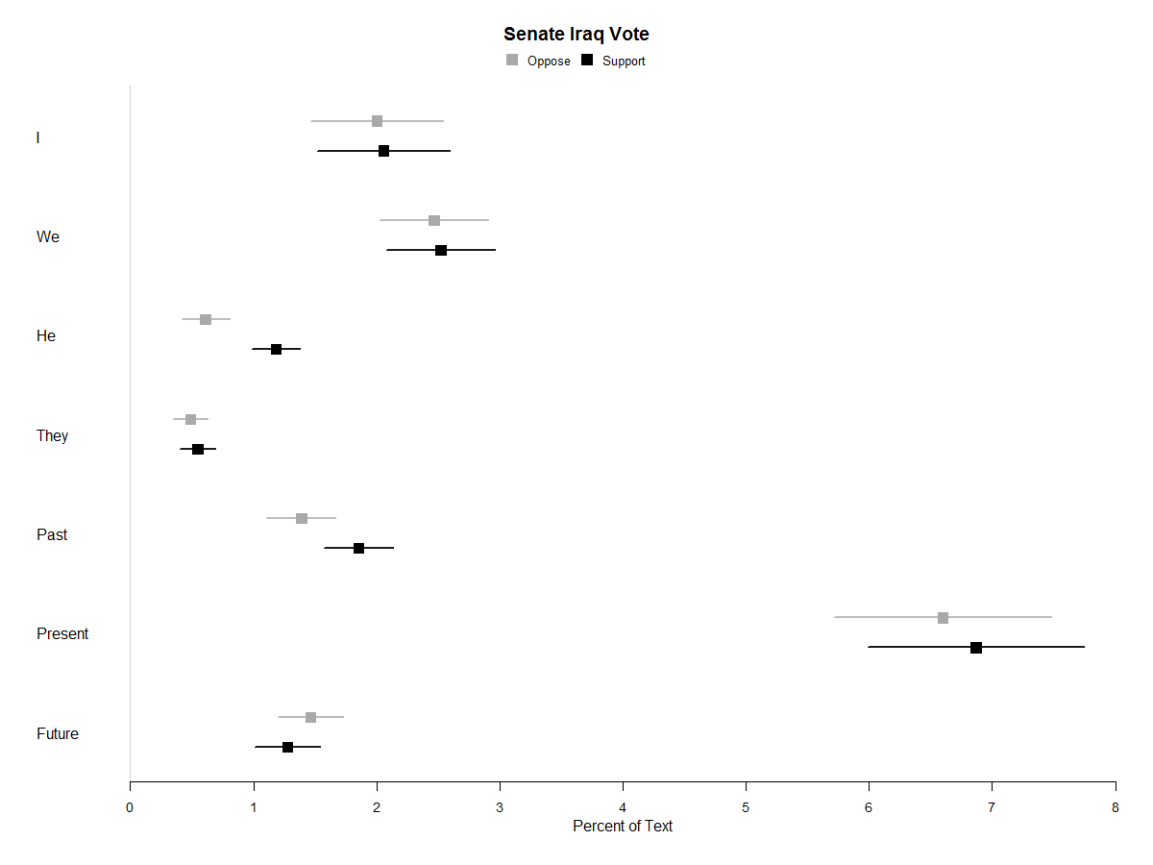

*Figure 4*

Attentional Differences in Senate Speeches preceding Iraq War vote

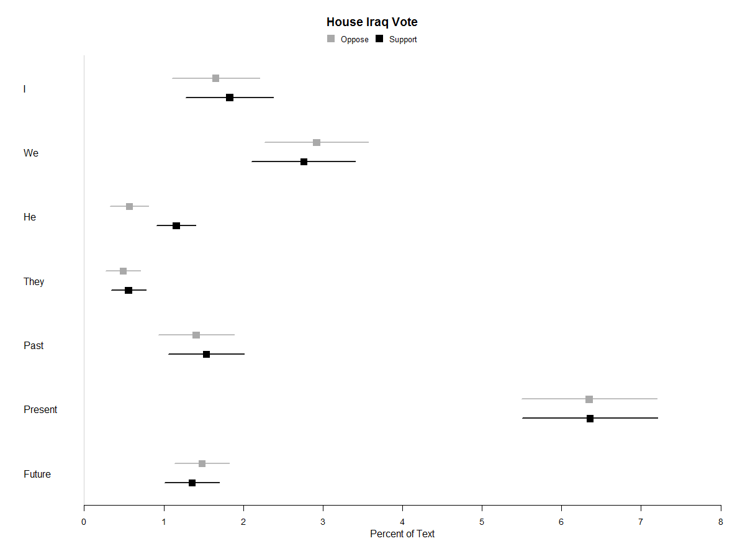

*Figure 3*

Attentional Differences in House Speeches preceding Iraq War vote

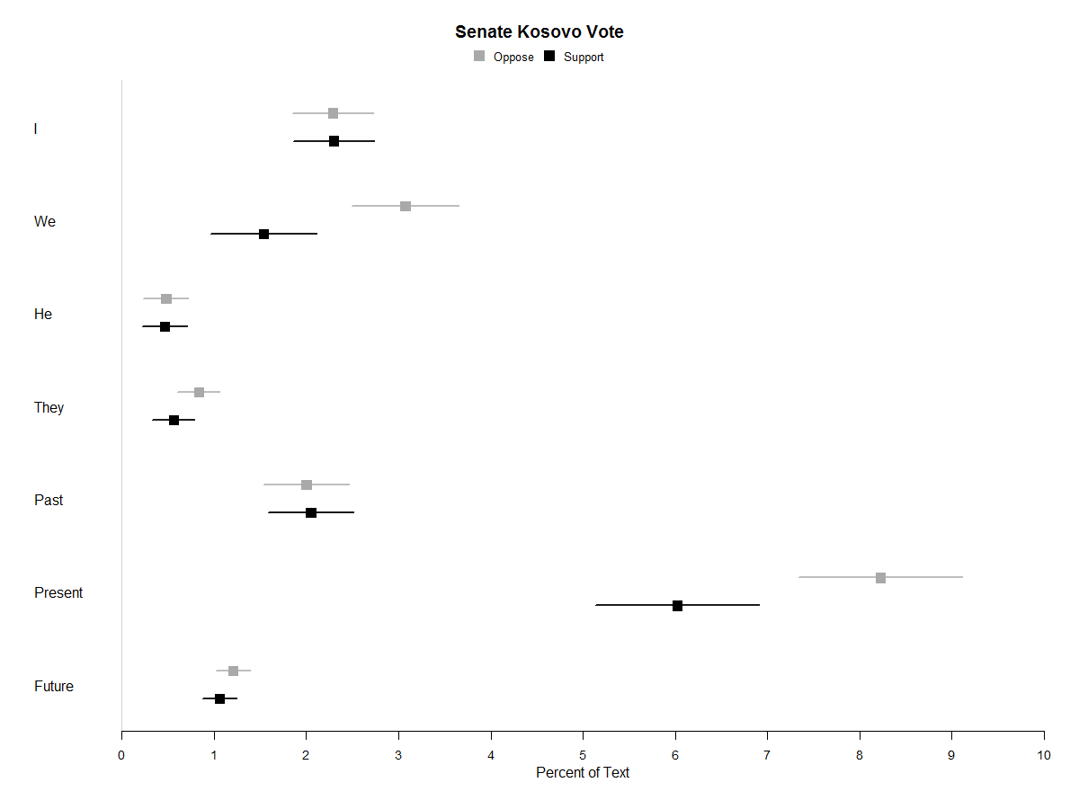*Figure 2*

Attentional Differences in Senate Speeches preceding Kosovo vote

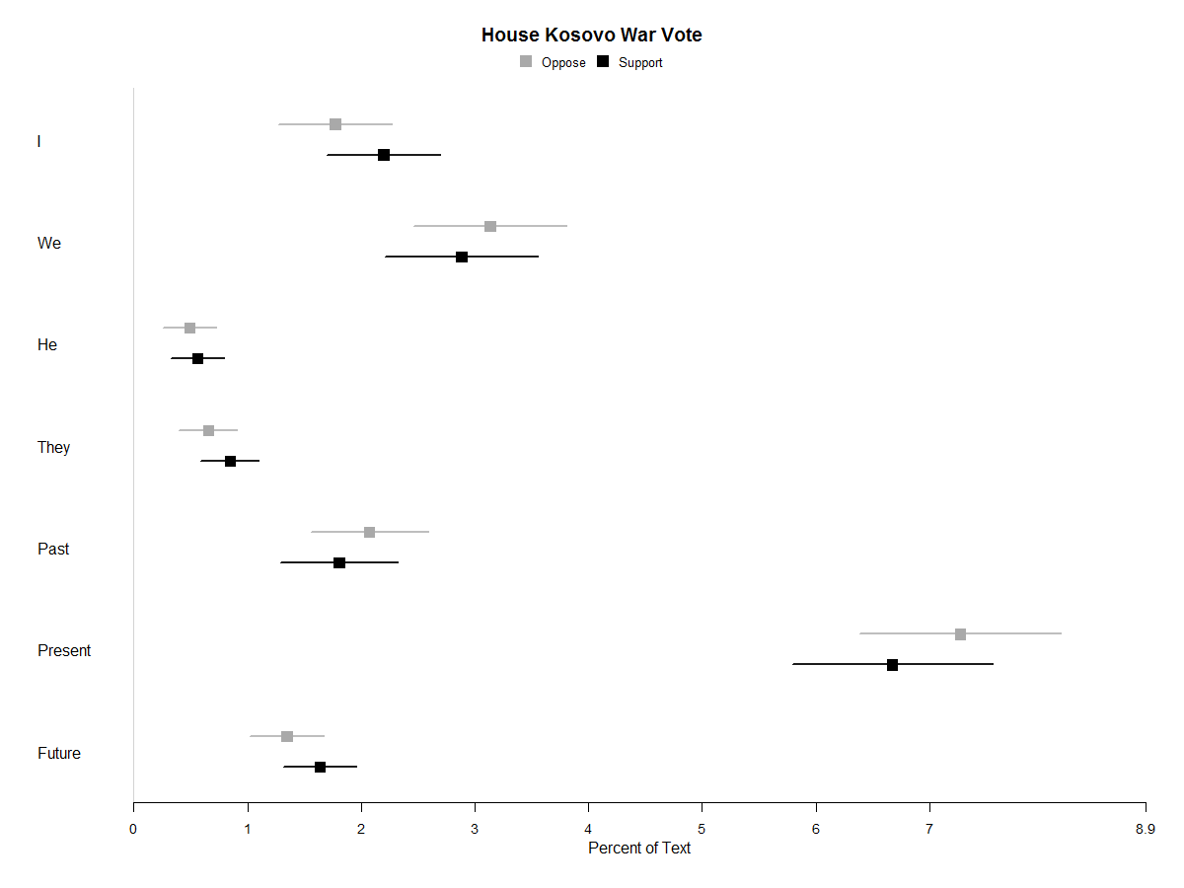

*Figure 1*

Attentional Differences in House Speeches preceding Kosovo vote

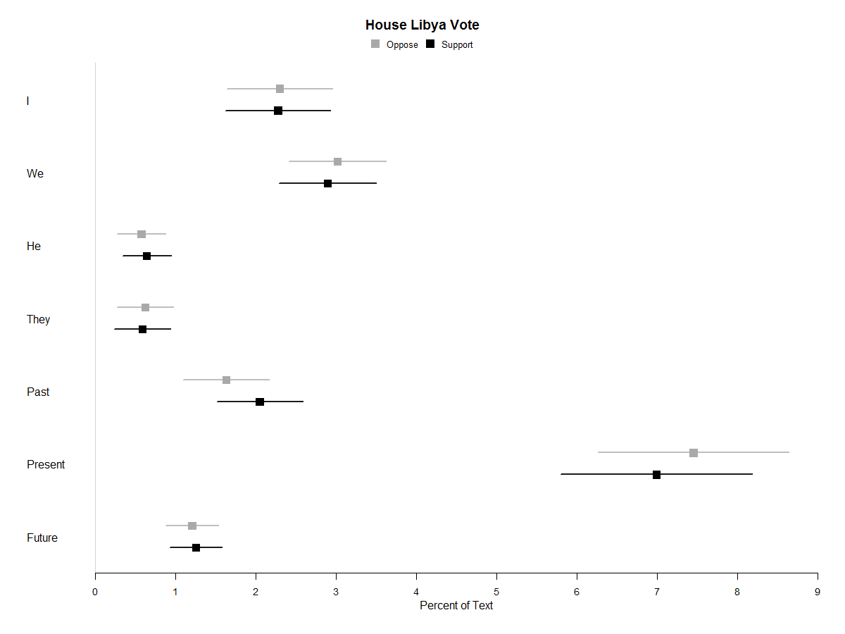

*Figure 5*

Attentional Differences in House Speeches preceding Libya vote

|  |  |  |  |  |  |  |
| --- | --- | --- | --- | --- | --- | --- |
| Chamber | Region | Word Type | *Mean Oppose* | *Mean Support* | *d* | Average *SD* |
| Senate | Iraq | I | 2.00 | 2.06 | .04 | 1.26 |
|  |  | We | 2.47 | 2.52 | .06 | .99 |
|  |  | **He-She** | **.61** | **1.18** | **1.15** | **.50** |
|  |  | They | .49 | .55 | .17 | .34 |
|  |  | **Past** | **1.39** | **1.86** | **.55** | **.85** |
|  |  | Present | 6.60 | 6.87 | .15 | 1.87 |
|  |  | Future | 1.46 | 1.28 | -.36 | .53 |
| House | Iraq | I | 1.65 | 1.83 | .15 | 1.17 |
|  |  | We | 2.92 | 2.76 | -.12 | 1.39 |
|  |  | **He-She** | **.57** | **1.16** | **.82** | **.72** |
|  |  | They | .49 | .56 | .13 | .53 |
|  |  | Past | 1.41 | 1.53 | .12 | 1.08 |
|  |  | Present | 6.34 | 6.36 | .01 | 1.74 |
|  |  | Future | 1.48 | 1.35 | -.19 | .68 |
| Senate | Kosovo | I | 2.29 | 2.30 | .01 | 1.15 |
|  |  | **We** | **3.07** | **1.54** | **-1.65** | **.93** |
|  |  | He-She | .48 | .47 | -.03 | .45 |
|  |  | **They** | **.83** | **.56** | **-.70** | **.39** |
|  |  | Past | 2.00 | 2.05 | .05 | .87 |
|  |  | **Present** | **8.23** | **6.03** | **-1.21** | **1.83** |
|  |  | Future | 1.20 | 1.06 | -.33 | .43 |
| House | Kosovo | I | 1.77 | 2.20 | .34 | 1.24 |
|  |  | We | 3.13 | 2.88 | -.15 | 1.71 |
|  |  | He-She | .49 | .56 | .11 | .60 |
|  |  | They | .65 | .85 | .26 | .74 |
|  |  | Past | 2.07 | 1.81 | -.23 | 1.15 |
|  |  | Present | 7.27 | 6.67 | -.27 | 2.17 |
|  |  | Future | 1.35 | 1.64 | .34 | .86 |
| House | Libya | I | 2.30 | 2.28 | -.02 | 1.25 |
|  |  | We | 3.02 | 2.89 | -.08 | 1.59 |
|  |  | He-She | .57 | .64 | .09 | .77 |
|  |  | They | .62 | .58 | -.05 | .70 |
|  |  | Past | 1.63 | 2.05 | .28 | 1.49 |
|  |  | Present | 7.45 | 6.99 | -.18 | 2.49 |
|  |  | Future | 1.20 | 1.25 | .06 | .76 |